Physics and Introduction to Science Topic Test 2

Name: _____________________________________ Mark: /54

**SECTION A: MULTIPLE CHOICE (15 marks)**

1. A B C D

2. A B C D

3. A B C D

4. A B C D

5. A B C D

6. A B C D

7. A B C D

8. A B C D

9. A B C D

10. A B C D

1. Inertia can be defined as:

A the amount of matter in an object

B a tendency of an object to resist a change in its motion

C the force of gravity on an object

D when a force makes something move

2. In what units is energy measured?

A kilograms

B kilometres

C joules

D metres

3**.** What units is force measured in?

A kilograms

B kilometres

C joules

D Newtons

4. Look at this picture.

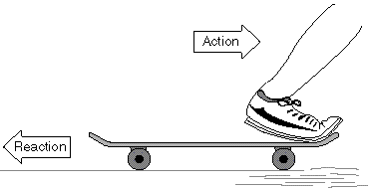

This is an example of:

a. Newtons 1st law of motion.

b. Newtons 2nd law of motion.

c. Newtons 3rd Law of motion.

d. Newtons 4th law of motion.

5. A ball is sitting still on the ground. It will not move until someone kicks it. This is an example of:

a. inertia

b. gravity.

c. friction.

d. potential energy.

6. A Cricket player hits a ball with a bat. The action force is the impact of the bat against the ball. The reaction force is…

a. The grip of the player’s hands on the ball

b. The air resistance on the ball

c. The force of the ball against the bat.

d. There is no reaction.

7. A force can be described as:

a. Anything that has mass.

b. Anything that has volume.

c. How fast an object is moving.

d. A push or a pull on an object.

8. Which of the following shows velocity?

a. A car moves North at 20Km/h.

b. A ship sails to Italy.

c. a bus takes John to school.

d. It is 10km to John’s school.

9. A 90 N force is applied to a 65 kg mass. The mass will accelerate at:

a. 0.72 m/s2

b. 1.2 m/s2

c. 1.4 m/s2

d. 5.9 m/s2

10. A spaceship is moving through space at 25,000 km/h. It will not change speed or direction unless something acts on it. This is an example of:

a. Newtons 1st law of motion.

b. Newtons 2nd law of motion.

c. Newtons 3rd Law of motion.

d. Newtons 4th law of motion.

**Short Answer (44 marks)**

**1**. **a**. Speed is a measure of how _________ an object is moving.

Speed shows how _________ something can travel in a set amount of ____________.

(3)

Calculate the average speed for both of the following. Show working.

**b.** Jay, who runs 2km in 2hours.

(3)

[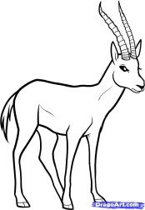](http://www.google.com.au/url?sa=i&rct=j&q=gazelle&source=images&cd=&cad=rja&docid=kwg2iPcbpPv3YM&tbnid=-Bu-rscZri4ugM:&ved=0CAUQjRw&url=http://www.dragoart.com/tuts/10091/1/1/how-to-draw-a-gazelle,-gazelle.htm&ei=qOEaUqjbFsiplQW34oCgCg&psig=AFQjCNGG6PYaOC_O64MCaluItuwxNoedSQ&ust=1377579809200925)**c.** A gazelle that runs 10 kilometres in 0.5 hours. (3)

2. What type of energy does this bullet have? Give a reason for your choice. (2)

[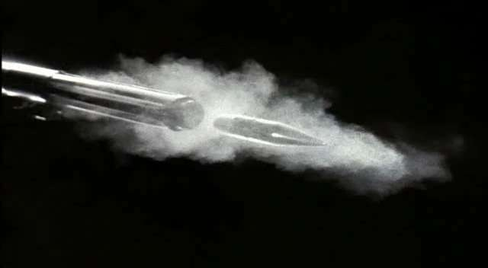](http://www.google.com.au/url?sa=i&rct=j&q=rifle+bullet&source=images&cd=&cad=rja&docid=UUtFTOhkAU_8LM&tbnid=pZLApBQq7IacmM:&ved=0CAUQjRw&url=http://www.spiritofbaraka.com/naqoy247&ei=_uAaUr-ZNcqQkwWgwoGgBg&psig=AFQjCNEY8-4bkQvSzwZzaGz_g2Ide4Tg9Q&ust=1377579630981788)

The equation below can help with questions 3 and 4.

[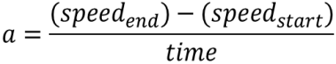](http://www.google.com.au/url?sa=i&rct=j&q=formula+acceleration&source=images&cd=&docid=n1BQvXMu3V1gnM&tbnid=tyy5e7co4fxZgM:&ved=0CAUQjRw&url=http://www.etorgerson.net/WebPages/ScienceUnits/A04_Acceleration.html&ei=ivH1UbrJMIiPkwW0pYD4Bg&psig=AFQjCNGKaO8mY3zS4cauOZdzzpsrQErjaw&ust=1375159034805046)

3. A bus is travelling at 40km/h. Its speed increases to 80km/h. This takes 10seconds. What was the acceleration?

(3)

4. A fish is swimming at 5km/h. It speeds up to 10km/h. This takes 2.5 seconds. What is the acceleration?

(3)

5. Kinetic energy= 1/2 of the objects Mass X the objects speed squared

[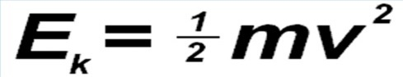](http://www.google.com.au/url?sa=i&rct=j&q=kinetic+energy+equation&source=images&cd=&cad=rja&docid=See6Fh-OKCTFWM&tbnid=Bc85jkUPcsgKhM:&ved=0CAUQjRw&url=http://www.formula1journal.com/2010/08/kinetic-energy-recovery-systems-by-sportsman.html&ei=_uUbUrrvGZDbkgWn84G4Dg&psig=AFQjCNGLnE1JnJzjXHzogdd9awRSOFrRjg&ust=1377646428409459)

A car has a mass of 2000kg and is moving at a speed of 5 m/s. How much kinetic energy does it have? Show all working.

(3)

6. Matter is anything that takes up ____________________ and has mass.

Mass is how much ____________________________ something has.

(2)

7. Newton’s Second Law of Motion

a. Newton’s second law of motion states that acceleration is produced when a force acts on a mass. The greater the m________ (of the object being accelerated) the greater the amount of f_________ needed (to accelerate the object).

(2)

b. The triangle below can be used to do calculations about Newtons Second Law of motion.

[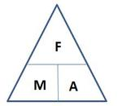](http://www.google.com.au/url?sa=i&rct=j&q=newton's%20second%20law%20triangle&source=images&cd=&cad=rja&docid=O6V53PkQA165NM&tbnid=vhNrW-efYEJTlM:&ved=0CAUQjRw&url=http://jdevlin.pottsgrove.wikispaces.net/Physics%2BTasks%2B2012&ei=wmMuUs7KL4m7lQXDyoGgAQ&psig=AFQjCNGR3tf1JJURHBC88bdwayoEOdZ0bg&ust=1378858254302715)

Fill in the spaces below for what the symbols in the triangle represents.

F = _______________ and is measured in ______________

M= _______________ and is measured in ______________

A= _______________ and is measured in ______________

(3)

c. Now use the triangle to find the answers to the questions below. Show all of the working. (9)

1. A force of 100N is applied to a ball of mass 2kg. What will the acceleration be?
2. A 21kg steel ball is accelerating at 3m/s2. What force was needed to bring this about?
3. What force will be needed to make a 2kg rock accelerate at 10m/s2?

8. Onto the grid on the next page draw a suitable graph for the data in the table below. The table compares the top speeds of different cars.

|  |  |
| --- | --- |
| Car | Top speed(km/h) |
| [Porsche 959](http://en.wikipedia.org/wiki/Porsche_959) | 314 |
| [Ferrari F40](http://en.wikipedia.org/wiki/Ferrari_F40) | 326 |
| [Jaguar XJ220](http://en.wikipedia.org/wiki/Jaguar_XJ220) | 342 |
| [McLaren F1](http://en.wikipedia.org/wiki/McLaren_F1) | 386 |
| Bugatti | 408 |

(6 marks)

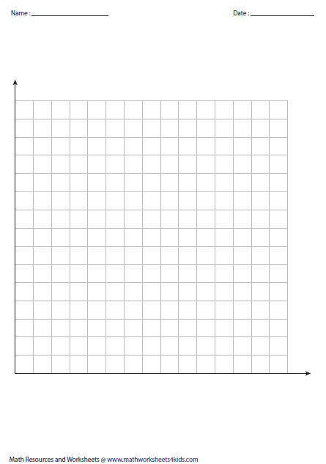

9. using the information from question 8, how far would the bugatti travel in 2 hours, if it was travelling at top speed?

(2 marks)